Roll No:241901017
Name: H.Bharath krishnan
Department: CSE-Cyber Security
CUSTOMIZED PING COMMAND TO TEST SERVER CONNECTIVITY
Aim:
To design a customized ping program that checks the connectivity between a client and a server by sending packets and measuring the response time.
Algorithm:
1.Start the program and input the server IP or hostname.
2.Send a test packet (ICMP or TCP) to the server.
3.Wait for a reply within a specified timeout.
4.If a reply is received, calculate and display the round-trip time (RTT).
5.If no reply is received, display “Request timed out.” 6.Repeat the process for a given number of times.
7.Display summary results (packets sent, received, lost, and average RTT).
PROGRAM:
import socket
import time
host = "google.com" # you can change this port = 80 # HTTP port
count = 4 # number of pings

for i in range(count):
try:
s = socket.socket()
start = time.time()
s.connect((host, port))
end = time.time()
s.close()
print(f"Reply from {host}: time={(end-start)*1000:.2f} ms") except Exception:
print("Request timed out")
if times:
print("\nMin RTT =", min(times), "ms")
print("Max RTT =", max(times), "ms")
print("Avg RTT =", sum(times)/len(times), "ms")
OUTPUT:
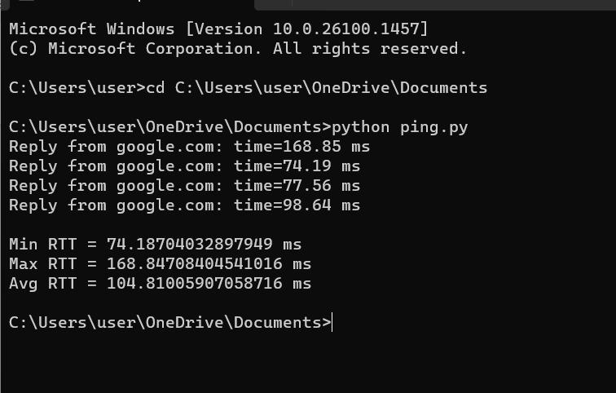

RESULT:
Therefore, customized ping commands was implemented and server connectivity was tested.

